**Event**

**Booklet**

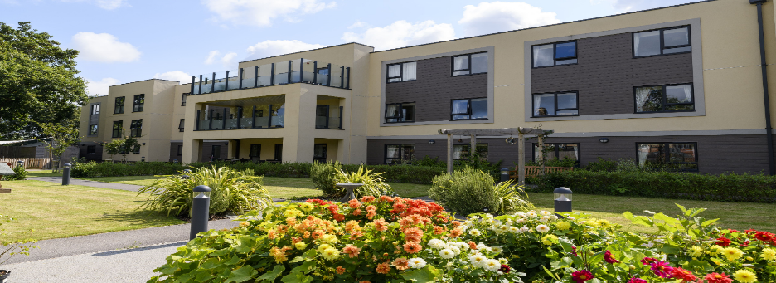

**Speedwell Court**

**Residential & Dementia Care Home** **Home**

**See enclosed for event information supporting**

**our local community**

**Dementia &**

**Carer Advice**

**& Support**

Lead by Andover Mind

**Day Care - Full or half days**

**Dementia Friends Session**

Learn how to become a dementia friend & help the community

**Community Sessions aimed at those living with dementia and their carers:**

* **Lunch Club**
* **Hairdressing Services**
* **Cinema Club**

**Please see inside for more details or pop in and look around**

Address: Mansbridge Road, Southampton SO18 3HW

T: 02382356990 / E: speedwell@abbeyfield.com



**‘FREE’ Dementia Friends Session**

**Speedwell Court, Mansbridge Rd, West End, Southampton SO18 3HW**

**Held monthly**

**What is a Dementia Friend?**

A dementia friend is somebody who learns about dementia so they can help their community from a professional or personal perspective.

By raising awareness & understanding we can support people living with dementia so that they continue to receive the respect & support they deserve.

A pin is given for each person completing the training.

To book a place please contact Justine Owen on 02382 356990 or email j.owen@abbeyfield.com

(Spaces are limited so please call to book your space)



A dementia friendly drop-in for carers of people with dementia. Join us for coffee & biscuits & receive advice & support.

**1st Wednesday of every month, from 2pm until 3:30pm**

To book contact [speedwell@abbeyfield.com](mailto:speedwell@abbeyfield.com) or call 02382 356990

Speedwell Court, Mansbridge Road, Southampton, SO18 3HW

**DAY CARE**



**Feel like you are home**

**Speedwell Court, Mansbridge Road, Southampton, SO18 3HW**

Full or half days on Mondays – Friday

Do you need some respite from being a carer?

Our full days are 9-5 including meals at just £85

Half days at £50

For more information please call us on: **02382 356990**

or email: **speedwell@abbeyfield.com**

**Speedwell Court**

**Community Lunch Club**

We facilitate a lunch once a month.

A dining experience in which to meet new friends in the same situation, enjoy a change of scene and have something nice to eat.

This free event is aimed at those with dementia & their carers, who would benefit from some company without the concern of another expense.

.

Spaces are limited so please book in advance

02382 356990 or [speedwell@abbeyfield.com](mailto:speedwell@abbeyfield.com)

**Speedwell Court, Mansbridge Road, West End, Southampton SO18 3HW (opposite Haskins)**

**Dementia Friendly**

**Hair Care**

**Always Glamorous Hair & Beauty**

Support the community to enjoy hair care services, including barbering.

With many years experience in providing person centred, dementia friendly treatments, we manage our clients with patience and dignity.

**Sessions are on the first Wednesday of each month between 13:30 – 15:30 Appointment required**

**Carers are welcome to sit & enjoy a coffee in the café while they wait**

**For more information, please call: 02382356990**

**Located at Speedwell Court Care Centre, West End, Southampton SO18 3HW**

**We would like to invite you to:**

**Speedwell Court’s**

**Community Cinema Club**

**Running the First & Third Friday of each month 2:30 – 4:30**

**Aimed at those living with dementia, and their carers, within our local community.**

Come along to our community cinema club & feel comfortable, safe & welcomed in our understanding & caring environment. There is no pressure to have to stay to the end.

* **Classic films from the 50’s, 60’s & 70’s (suggestions welcome).**
* **Singalongs, upbeat & timeless movies to evoke good times & good memories.**
* **Refreshments provided.**

Call **02382 356990** or email [**speedwellcourt@abbeyfield.com**](mailto:speedwellcourt@abbeyfield.com) to find out more